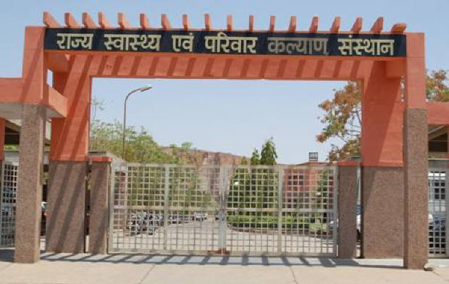
SIHFW Rajasthan

Electronic Newsletter
April to August 2026 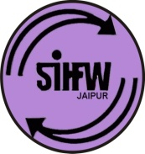
SIHFW: an ISO 9001:2015 certified Institution
From the Director’s desk…

Dear Readers…

This year we celebrated 80th Independence Day of India. At SIHFW, with all staff we celebrated, with a commitment to bring Youth forward in health awareness since the theme “Role of youth under the theme “Yuva Shakti for Viksit Bharat@2047” also focuses on strength of youth in our country. Active participation of youth in nation-building and harnessing the full potential of India’s young population is crucial for a more responsible and aware India. Youth play a crucial role in the health sector by participating in health initiatives, advocating for health equity, and contributing to the design and implementation of health policies and programs. Their involvement is essential for creating health initiatives that are relevant and successful, as they bring creativity, lived experience, and unique insights. Youth participation also equips them with important life skills such as teamwork and communication, building their confidence and sense of purpose.

This newsletter carries information on important activities organised during April to August 2026.

Best Wishes!!

Registrar-SIHFW

Some important health and social days for April to August
World Autism Awareness Day –April 2 | World Environment Day- June 5
World Health Day-April 7 | International Day of Yoga-June 21
World Parkinson Day-April 11 | International Day against Drug Abuse and Illegal Trafficking- June 26
National Safe Motherhood Day-April 11 | Doctors’ Day-1 July
World Hemophilia Day-April 17 | World Population Day- July 11
Earth Day-April 22 | World Brain Day- July 22
World Malaria Day-April 25 | World IVF Day- July 25
World Day for Safety and Health at Work-April 28 | World Hepatitis Day- July 28
World Hand Hygiene Day- May 5 | World Lung Cancer Day- August 1
World Asthma Day -May 5 (first Tuesday of May) | Indian Organ Donation Day- August 3
World Thalassemia Day -May 82024 | World Breastfeeding Week-August 1-7
Anti-tobacco Day- May 31 | World Organ Donation Day- August 13
International Day for Action of Women’s Health- May 28
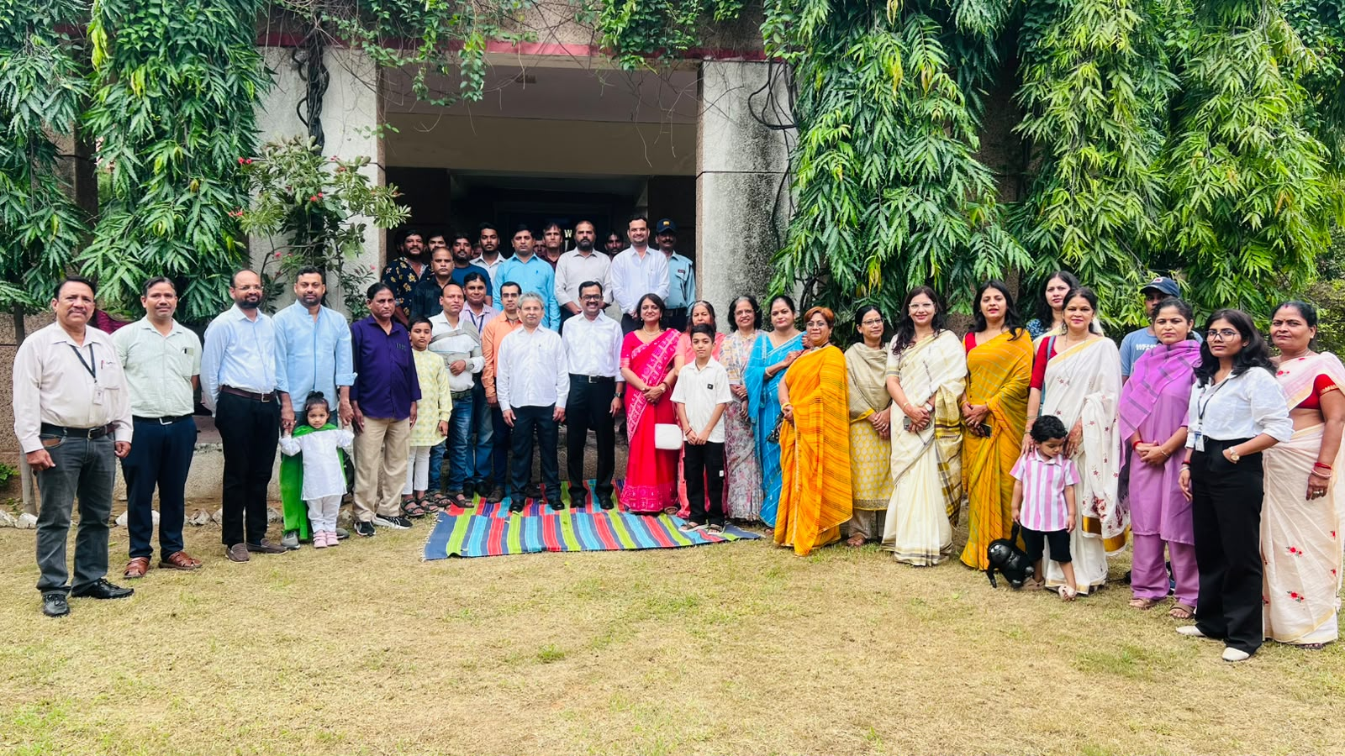
Independence Day Celebration at SIHFW, August 15, 2026

Workshops at SIHFW
Workshop on Constitutional Values Based Fellowship
This was a 5 days workshop organized at SIHFW on April 7 to 11, 2026.

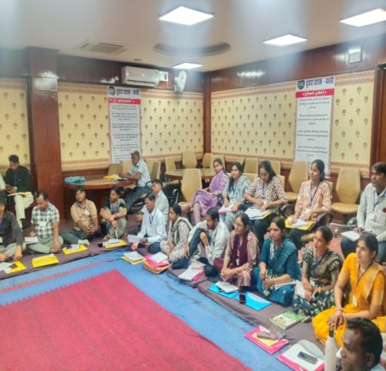
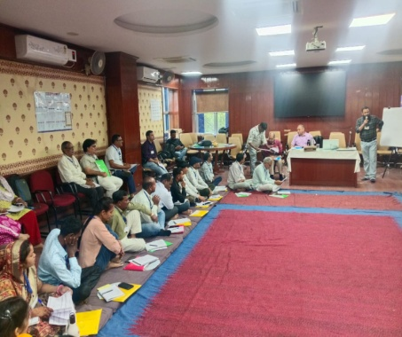

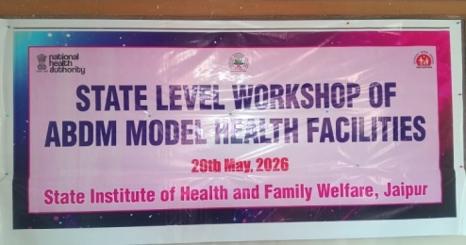
State Level Workshop of ABDM Model Health Facilities
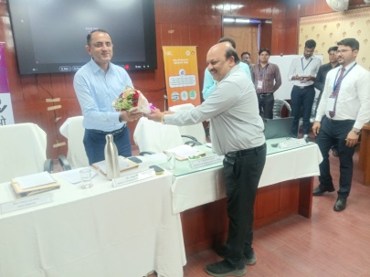
The Ayushman Bharat Digital Mission (ABDM) model health facilities are integral to the digital health ecosystem in India. These facilities are registered in the Health Facility Registry 9HFR), which is a comprehensive repository of all health facilities across different systems of medicine. The HFR includes both public and private health facilities, such as hospitals, clinics, diagnostic laboratories and imaging centres, pharmacies, etc. ABDM aims to ensure that all health care providers are part of the digital health system, facilitating interoperability and enhancing the overall healthcare delivery process.
A state level workshop was organized on ABDM model health facilities, at SIHFW on 20th May 2026.
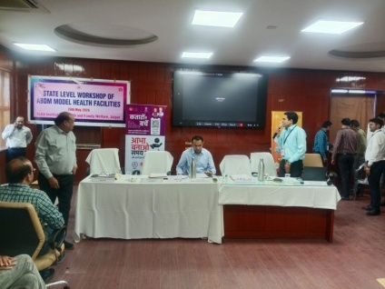
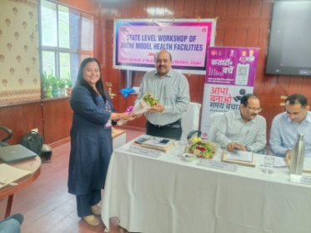
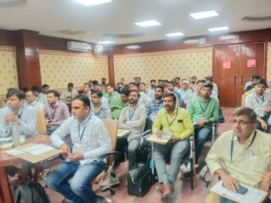

One day workshop for Digital Health Initiatives and their effective implementation

Four workshop of one day each were organized at SIHFW on August 4, 5, 6 and 7 August, 2026. In first workshop District IEC coordinators participated, in second DPC MAA yojana participated, in third and fourth workshop IA/AP participated.

A one day training was organized at SIHFW on August 6 for District Program Coordinators- MAA Yojana (ABDM).
Zone level ABDM and E Governance Workshop and training
One day workshops were organized for zone level staff under ABDM. These 4 workshops were organized on 29 and 30 June 2026 and 1 and 2 July, 2026.

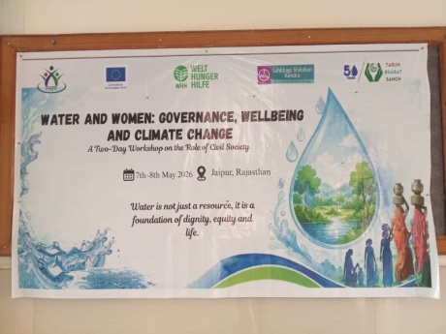
Water and Women: Governance Wellbeing and Climate Change
This was a two day workshop organized at SIHFW On May 7-8. 2026. It was jointly organized by Sehbhai Shikshan Sansthan NGO, Welt Hunger Hilfe (WHH), EU and Tarun Bharat Sangh. The workshop was focused on role of civil society.
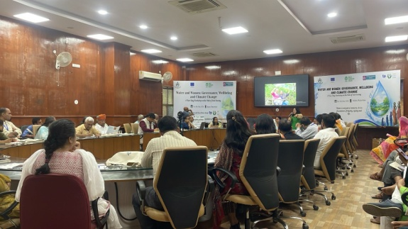

Rootcause analysis of Vaccine Preventable Diseases
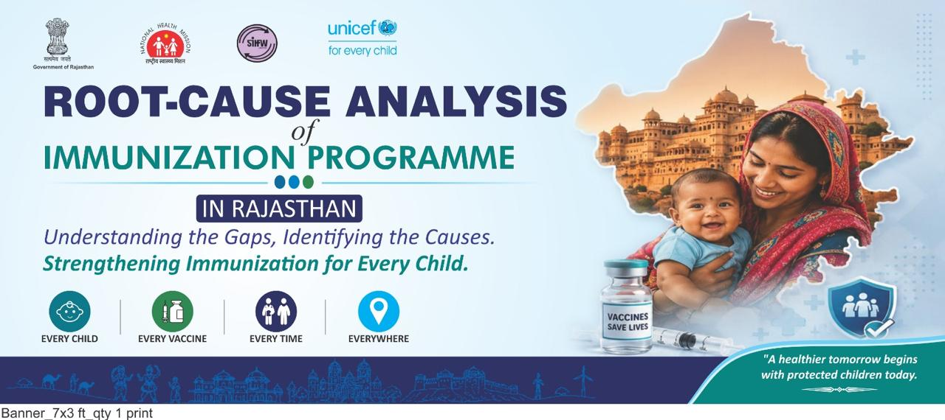
This was a research study conducted by UNICEF in 20 districts of Rajasthan. Two researchers from SIHFW also visited fields for data collection. Data was collected through mobile ODK. Data was later analyzed and disseminated at a workshop organized at SIHFW on 13 July, 2026. Gaps of SBCC were also identified in the study. A message was given to all RCHOs through live video meeting and RCHOs also shared their suggestions.

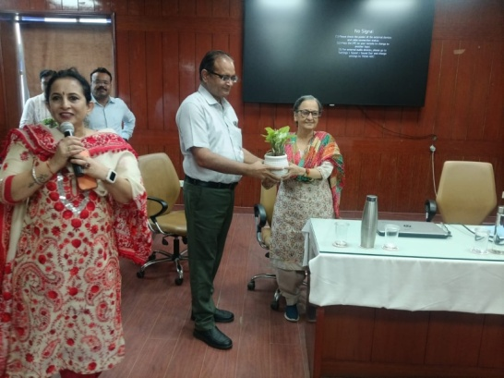

Before the dissemination workshop, researchers were given orientation on July 6, 2026 at SIHFW. Participants included SIHFW staff, RCHOs, UNICEF, UNDP and WHO consultants and officials. Dr. Madhu Rateshwar, Director RCH was facilitated with a plant at the inaugural session of the workshop.

State Level Workshop on GIPA and Social Protection under RSACS
This was a 2 days workshop organized at SIHFW on June 24-25, 2026. 45 participants from LGBTQ+ community participated in this workshop.

Trainings at SIHFW
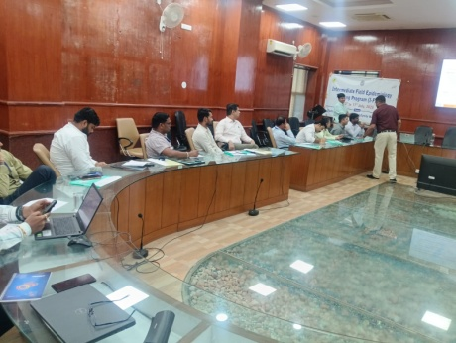
Intermediate Field Epidemiology Training Programme
This was a 5 day training program organized at SIHFW during July 13 to 17, 2026. Dy CMHOs participated in this training. Number of participants was 20.

Trainings on Homeopathy
Four training batches on Homeopathy were organized at SIHFW. Training of Homoeopathy Medical officer, Nurse & Compounder was organized on May 22, 25, 26 and 27, 2026. Number of participants were 108, 100, 102 and 105 respectively. Homeopathy Medical Officers were trained in these training batches.
Agriculture and Livestock Orientation
State Resource Persons were given an orientation on Agriculture and Livestock on June 15 to 18, 2026 at SIHFW. 45 participants were trained in this training. It was organized under RGAVP.
Lakhpati Didi Master Trainer Training of Trainers (ToT) Programme

Three batches of Lakhpati Didi ToT were organized at SIHFW on June 8-9 (75 participants), 10-11 (80 participants) and 12-13, 2026 (77 participants). This was a 2 days ToT and RGAVP staff participated in this training.
Lakhpati Inititative Orientation training was organized at SIFHW on June 19-20, 2026. 33 RGAVP staff were trained in this training.

Refresher Training of Counselors on AFHS

One day refresher training course on AFHS was organized at SIHFW on 12 August, 2026. RKSK counselors and UNFPA coordinators participated in this training. Number of participants was 63.

Mission Madhuhaari (NP-NCD)

Mission Madhuhari is a government health initiative in Rajasthan and Madhya Pradesh focused on providing early detection, regular treatment, and free insulin-based care for children and youth (up to 18 years) living with Type-1 diabetes. It includes weekly clinics, free glucometers, glucose strips, and trained staff in designated government hospitals and schools. Following are the key features:
- Target Disease: Dedicated exclusively to managing and treating Type-1 Diabetes in children, adolescents, and young adults.
- Free Supplies: Provides free-of-cost insulin, glucometers, glucose testing strips, syringes, and monitoring logbooks at designated district hospital clinics.
- Support & Counseling: Offers regular health check-ups, lifestyle counseling, and 24/7 support via helplines like MadhuVani.
- Technological Integration: Utilizes advanced tracking, AI digital twin platforms (MadhuRoop), and screening tools to predict glucose fluctuations and manage long-term care.
- Recent Expansion: Scaled up across government district hospitals, schools, and colleges to ensure uninterrupted medical supply through a dedicated "Madhuhari Bank".

Trainings on Mission Madhuhari are organized at SIHFW under NP-NCD program. A training was organized for Medical Officers for 2 days. There were 39 participants. It was organized during 19 to 20 May 2026. A batch was also organized during April 15-16, 2026 at SIHFW where 71 specialists participated.

Training on COPD under NPNCD

One day training batch was organized on COPD for Staff Nurses. It was of 2 days and was organized under NP-NCD program. It was organized on May 11, 2026 and 27 Staff Nurses participated in this training batch.
Training on Raj Kidney Care under NP-NCD

This was a once day training at SIHFW. Mix group of participants included Medical Offices, Lab technicians and Nursing Officer. It was organized on June 22, 2026 and 44 participants were trained in this batch.
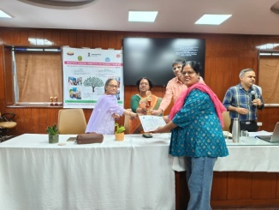

RKSK Orientation cum training program for counselors

This was a one day training of RKSK counselors under RKSK program. It was organized at SIHFW on 12 August, 2026. 71 participants were present at this training.

Review Meetings
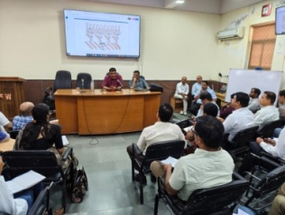
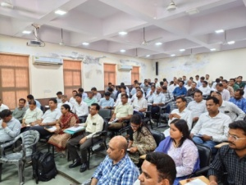
Two review meetings were organized at SIHFW on Vaccine Preventable Diseases (VPD) Surveillance. These meetings were chaired by Dir PH and sessions were delivered by IDSP officials from DMHS. First meeting was on April 27, 2026 where 80 participants Dy CMHO, RCHOs and Epidemiologists were reviewed. Next meeting was on June 12, 2026 and 22 Dy CMHO and RCHOs were present.
Review Meetings under NP-NCD

8 Review meetings were organized at SIHFW under NP-NCD during August month. These were organized for Jaipur, Bikaner, Bharatpur and Ajmer zones. These were one day review meetings organized on August 12 (55 participants), 19 (31 participants), 21 (43 participants) and 31 (30 participants) . Dy CMHOs, BCMOs, DPO, BPO, FCLO and CHOs were participants in these meetings.

Review Meetings cum trainings under RSACS

8 Review meetings were organized during May to August 2026 at SIHFW. Out of these 8, in four meetings cum trainings participants were ICTC counselors and DAPCU staff under RSACS and 200 participants were trained. In one more review meeting cum training organized on May 20-21, 2026 participants were ART centre Data Managers and counselors under RSACS and 69 participants were trained. In another 2 days review meeting cum training organized at SIHFW, August 10-11, 2026, STI counselors under RSACS were trained.

Capacity Building of Field Functionaries

2 batches of 3 days training was organized at SIHFW to give training to Field functionaries under RSACS. These batches were organized on August 12 to 14 and August 19 to 21, 2026. Number of participants in these batches was

One day Review meetings were organized for STI counselors under RSACS and Lab Services under RSACS in 2 batches organized on May 18 (53 participants) and 19, 2026 (14 participants).

Training on EVTHS under RSACS

3 batches of these trainings were organized on July 23-24, 28-29 and 30-31, 2026 at SIHFW. Total 177 participants were trained in these trainings including counselors and DAPCU staff.
Staff Meetings at SIHFW

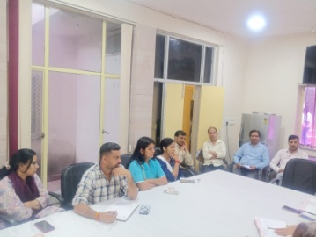
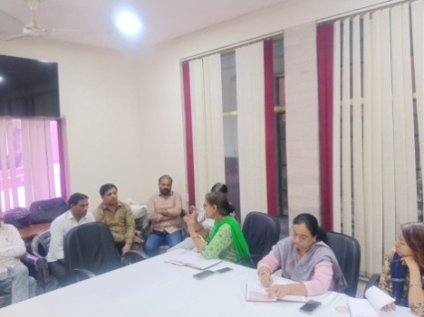
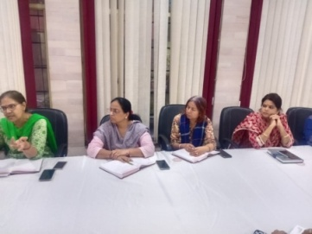

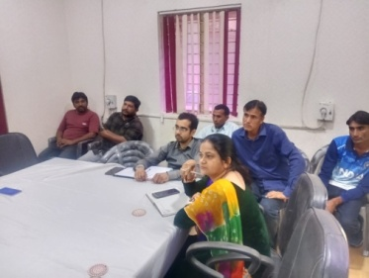
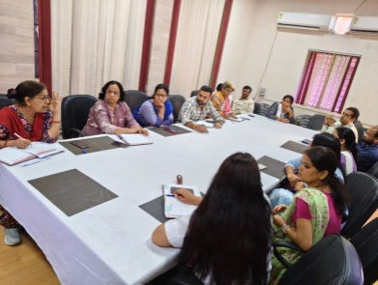

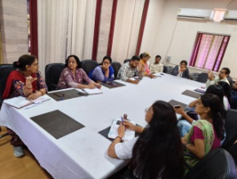
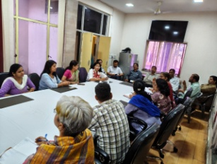

Participation from SIHFW
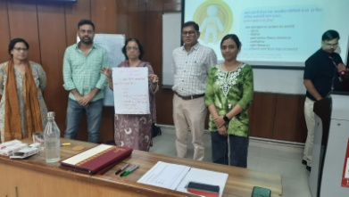
Master Trainer Workshop “Karmyogi Kartavya Karyakram”
Dr Bharti Sharma, Faculty SIHFW and Ms Nishanka Chauhan, STA and Mr Vikas Bhardwaj, STA participated at a 2 days training Master Trainer Workshop “Karmyogi Kartavya Karyakram”at HCM RIPS on July 16-17, 2026.
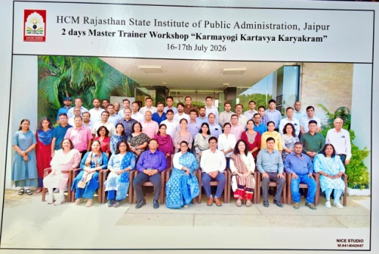
Karmayogi Kartavya Karyakram marks a significant step in advancing Mission Karmayogi’s vision of building a citizen-centric and future-ready civil service. The roadmap outlines a phased national rollout from April 2026 to December 2028, aimed at institutionalising Seva Bhav across Central and State Governments through large-scale behavioural capacity building. Targeting nearly 1.3 crore officials, particularly frontline functionaries in key sectors, the programme will leverage a robust cascade training model supported by National Lead Trainers, State Master Trainers, and the iGOT digital learning platform. The roadmap provides a structured pathway for scale, standardisation, and sustainability, culminating in the integration of behavioural learning within institutional training ecosystems across government.
It was a participative workshop which involved participants from interdepartmental sectors such as education, colleges, ACB, etc.
In Service Orientation Training course on Health Information Management for Officers
Ms. Archana Saxena, JTA, SIHFW participated at a 5 days training on August 3 to 7, 2026. The training was organized by CBHI, MoHFW, GoI. The training was based on NHM and key components of information management system. The training included a field visit to record room of SMS Medical College and Hospital.
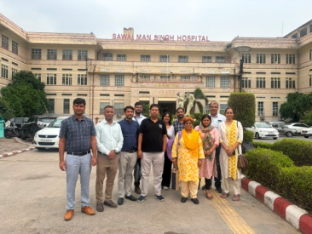
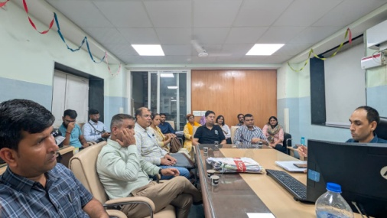

Health News

International News:

WHO launches global research priorities on climate health and migration

WHO Health and Migration, in collaboration with WHO Climate Change, Energy and Air Quality, launched the Global research prioritization and action plan on health, migration and displacement in the context of climate change during a virtual webinar on 22 July 2026, bringing together more than 300 participants from over 75 countries to advance evidence and action on one of the most pressing and under-researched global health challenges.
The Global Research Prioritization Exercise (GRPE), the first thematic deep dive under WHO’s Global research agenda on health, migration and displacement, was developed to address these challenges and support WHO’s commitment to generating robust, policy-relevant evidence for equitable and migration-inclusive health systems. The exercise followed a structured, participatory approach, including a scoping review, stakeholder mapping, technical consultations and an online prioritization survey, engaging 59 experts from academia, policy and practice across disciplines, sectors and regions.
The GRPE identified priority research areas across three core themes – social determinants of health, universal health coverage and emergencies – alongside two cross-cutting areas: health outcomes and data, policy and interventions. It also produced a global action roadmap to guide future research, policy and practice. Key priorities identified include addressing social inequities and vulnerabilities, strengthening access to health systems and services, improving preparedness and resilience to climate-related emergencies, enhancing migration-sensitive data systems, and generating evidence on mental health, maternal and child health, chronic diseases, and the long-term impacts of climate-related mobility.
The launch reinforced a shared commitment to strengthen interdisciplinary collaboration and ensure that research informs policy and practice. Discussions highlighted the need to break down silos across climate, health and migration sectors, strengthen migration-sensitive data systems, promote participatory and community-centred research, and translate evidence into practical policies and interventions that respond to the realities of affected populations. Participants also underscored the importance of sustained partnerships and stronger links between research, policy and implementation.
“Climate change is already affecting the health and mobility of populations around the world. Strengthening the evidence base is essential to inform effective policies and ensure that those most affected are protected through climate-resilient and equitable health systems,” said Dr Diarmid Campbell-Lendrum, Head of WHO Climate Change, Energy and Air Quality.
(Source: WHO/Media/Press release, August 5, 2026)
Road deaths fall by 21% globally but stronger action is needed to save lives
Despite the addition of more than one billion motor-vehicles to the world’s roads, the global rate of road traffic deaths declined by 21% between 2011 and 2025, according to new data released by the World Health Organization (WHO).
The world has experienced profound changes in road traffic during this time with the emergence of new modes of transport and a sharp rise in motorcycle use. Despite this progress, however, road traffic crashes still claimed 1.16 million people's lives in 2025. Road traffic injuries remain the leading cause of death among children and youth aged 5–29 years.
The new WHO data comes as global leaders today adopt a new United Nations (UN) General Assembly progress declaration on road safety. The declaration aims to boost global action to meet the Sustainable Development Goal (SDG) target of a 50% reduction in road deaths and serious injuries by 2030 compared with the levels in 2021.
“This progress shows that change is possible when countries invest in safe road systems. In the last 15 years we’ve made real progress in reducing road deaths, despite surging vehicle numbers and major shifts in how people move,” said WHO Director-General Dr Tedros Adhanom Ghebreyesus. “I commend countries for the strong political declaration they are adopting today, which aims to accelerate action to ensure more roads are designed for people first, not motor vehicles, with safety as priority. All road deaths are preventable and none are acceptable.”
The new UN declaration includes a comprehensive set of commitments by UN Member States to implement national road safety strategies with clear targets, timelines and budgets. These commitments include establishing lead road safety agencies, improving data collection and analysis, developing and enforcing stronger legislation, and ensuring that roads, infrastructure and vehicles meet key safety standards.
The declaration commits countries to implementing the proven ‘safe system’ approach, which recognizes that people will always make mistakes on the road. The approach promotes safer roads, infrastructure, vehicles, speed limits and regulations that account for human error and ensure that crash impacts remain within survivable levels. It also calls on governments to provide leadership and take additional action, and urges the private sector to prioritize road safety throughout their supply chains. The declaration also highlights the important roles of civil society, academia, youth, philanthropic organizations and the UN in driving progress.
With nearly 60% of the world’s population now living in urban areas, growing demand for mobility threatens to overwhelm transport systems that were largely designed around private motor vehicles.
With the rise of ride-hailing and delivery apps, the number of motorcycles more than tripled between 2011 and 2025. Deaths among motorcyclists now account for nearly a third of the world’s road fatalities. Wearing a safe motorcycle helmet reduces the risk of death in a crash by more than six times.
New forms of mobility, including e-scooters, e-bikes and autonomous vehicles, present both challenges and opportunities for transport planners and policy-makers. WHO is working to close gaps in laws and rules, promote consistent safety standards and is bringing together leading experts to find new ways to ensure all new vehicles and technologies are safe.
“More than half of all road deaths are people who aren't even in a car – they are walking, cycling or riding a motorcycle. When roads are designed as if only car drivers matter, these people are left dangerously exposed,” said Dr Etienne Krug Director of the Department of Health Determinants, Promotion and Prevention at WHO. “We know what works – strong laws and enforcement, safe infrastructure and vehicles with particular attention to lowering speed and addressing impaired driving. This declaration means we must all go further and faster.”
Across the world, 10 countries reduced road deaths by 50% in the decade to 2021 and more than half of all countries reported falling fatalities in that period. Yet progress is uneven, with 36% drop in deaths in the WHO European Region, a 15% drop in the Western Pacific Region, a 2% drop in the WHO South-East Asian Region, no change in rates in the Americas and a 17% rise in deaths in the WHO African Region.
The new UN declaration states that strengthening road safety is key to improving public health and sustainable development overall. More people choosing to walk, cycle and use public transport can reduce congestion, improving air quality, create more livable cities, and support healthier, longer lives. (Source: WHO/Media/Press release, July 20, 2026)

India News:

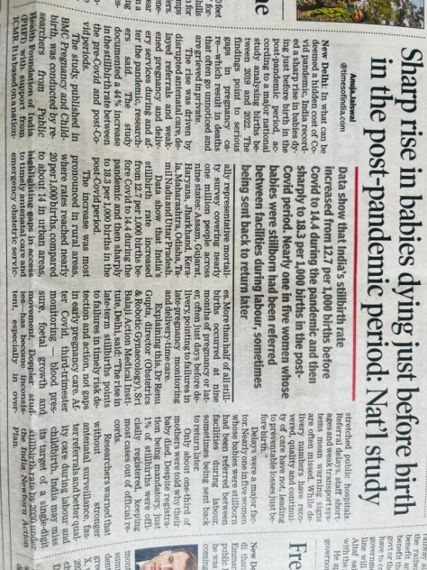

ICMR-NIN-led ‘Let’s Fix Our Food’ Consortium Releases Policy Priorities to Promote Healthier Diets for Children and Adolescents

The Indian Council of Medical Research–National Institute of Nutrition (ICMR-NIN)-led 'Let's Fix Our Food' (LFOF) Consortium today released a policy document titled 'Priority Policy Actions to Promote Healthier Diets and Food Environments for Children and Adolescents in India', outlining evidence-based recommendations to support healthier food environments and improve dietary behaviours among children and adolescents across the country.
The policy document was launched by Dr. M. Srinivas, Member (Health), NITI Aayog, during the LFOF Dissemination and Consultation Workshop held at the India Habitat Centre, New Delhi, in the presence of Dr. Bharati Kulkarni, Director, ICMR-NIN, Prof. (Dr.) K. Srinath Reddy, Founder President, Public Health Foundation of India (PHFI), and senior representatives from the Ministry of Health and Family Welfare, FSSAI, UNICEF India, Resolve to Save Lives (RTSL), consortium partner institutions, researchers, development partners and youth representatives.
The Let's Fix Our Food (LFOF) Consortium is a multi-institutional national platform led by ICMR-NIN, with participation from Resolve to Save Lives (RTSL) India, UNICEF India, Global Health Advocacy Incubator (GHAI), PHFI, WHO, FSSAI, IEG, WFP, Lady Irwin College, IFPRI, Deakin University and other national and international partners. Through research, policy analysis, advocacy and stakeholder engagement, the Consortium seeks to support India's efforts to prevent diet-related non-communicable diseases by transforming food environments, particularly for children and adolescents.
The publication brings together nearly three years of multidisciplinary research, stakeholder consultations and policy dialogues. It sets out policy recommendations across key areas, including healthy school food environments, nutrition literacy, front-of-pack nutrition labelling, regulation of marketing of unhealthy food to children, taxation of foods high in fat, salt and sugar (HFSS), healthier dietary fats, salt reduction, low-sodium salt substitutes, social and behaviour change communication, youth engagement and fiscal measures to promote healthier diets.
Speaking on the occasion, Dr. M. Srinivas, Member (Health), NITI Aayog, said, "Evidence-based, multisectoral policy action is essential to create healthier food environments for children and adolescents. Collaborative initiatives such as the Let's Fix Our Food Consortium are important for addressing the growing burden of overweight, obesity and diet-related non-communicable diseases in India."
Dr. Bharati Kulkarni, Director, ICMR-NIN, said, "ICMR-NIN is committed to generating high-quality evidence and fostering partnerships that translate research into public health action. The policy recommendations reflect the collective efforts of researchers, policymakers, development partners and young people working towards healthier food environments for India's future generations."
Prof. (Dr.) K. Srinath Reddy, Founder President, Public Health Foundation of India (PHFI), underscored the need for comprehensive policy interventions addressing the commercial, social and environmental determinants of unhealthy diets, and called for sustained action to protect children and adolescents from obesogenic food environments.
The workshop also witnessed the launch of several knowledge products developed under the Consortium, including the LFOF website, the Nutrition Environment Assessment Toolkit for Schools (NEAT-S) and its report, an e-learning module on understanding food labels, and a suite of ICMR-NIN educational resources on fats, sugars and salt to strengthen nutrition literacy among children and adolescents.
Marie-Claude Desilets, Chief of Nutrition, UNICEF India, said, "Malnutrition is no longer only about under-nutrition. Rising obesity, driven by unhealthy diets, challenges healthy growth among children and adolescents. The release of these ten policy briefs and the Nutrition Environment Assessment Toolkit for Schools (NEAT-S) marks a step towards creating policies for healthier school food environments. Every child has the right to grow up in a food environment that enables them to thrive, learn and achieve their full potential."
Dr. Syed Imran Farooq, Executive Director, Resolve to Save Lives (RTSL), highlighted the need to reduce excess salt, fat and sugar intake alongside food policies that support healthier food environments and lower the burden of cardiovascular diseases and other health threats. He also acknowledged the leadership of ICMR-NIN and reaffirmed RTSL's commitment to the shared vision of healthier food environments across India.
The consultation showcased new evidence generated by consortium partners on school food environments, unhealthy food marketing, nutrition education, dietary behaviours, fiscal policy options and nutrition environment assessments across multiple states. The workshop concluded with thematic discussions on translating evidence into actionable policy recommendations to support healthier food environments for children and adolescents.
The Let's Fix Our Food Consortium was established to generate evidence and catalyse policy action for healthier food environments in India, with a special focus on children and adolescents. The policy priorities released today draw on multidisciplinary research and consultations and seek to support efforts to prevent diet-related non-communicable diseases through coordinated, evidence-informed action. (Source: 22 JUL 2026 by PIB Delhi)

We solicit your feedback:
Editing and Compilation by: Archana Saxena, JTA; IT support: Mohit Dhonkeriya,State IT Coordinator;
Mentored by: Dr Bharti Sharma, Faculty-Gynaecology, SIHFW
State Institute of Health & Family Welfare
Jhalana Institutional Area, South of Doordarshan Kendra Jaipur (Raj)
Phone-2706534
E-mail:-sihfwraj@ymail.com; Website: www.sihfwrajasthan.com

